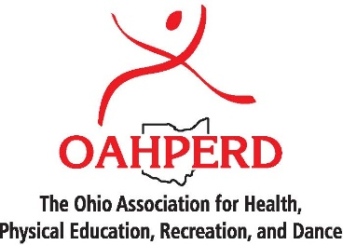

**Convention Attendance - Justification Letter**

<*Date>*:

Dear < Name of Supervisor*>*:

Research has proven that health and physical education (H/PE) provide many benefits for students, including improved concentration, on-task behavior, attendance, and academic achievement. These reasons are a primary factor in ESSA’s new definition of a well-rounded education that includes H/PE.

To further strengthen my contributions to (our school district’s) education programs, I would like to take advantage of a professional development opportunity that will support my teaching and ultimately enhance our work to educate the “whole child.”

The Ohio Association for Health, PE, Recreation, and Dance, the state’s largest organization of health and physical education professionals, will be holding its Annual State Convention in Sandusky November 29 – December 1. During this convention I will have the opportunity to:

* Stay up-to-date on best practices in curriculum and instruction, such as teaching Standards-Based Lessons, Social & Emotional Learning, and Conflict Management
* Gather information on the latest instructional and assessment tools
* Understand the role and use of technology in learning experiences
* Learn instructional techniques, activities and assessment ideas for students with disabilities
* Meet with exhibitors offering the latest equipment, programs, and resources

The scheduled presentations incorporate the most recent findings on best practices, with a focus on strategies to successfully engage students. Many of the sessions will also highlight how to leverage existing resources to enhance our programs at little to no extra cost.

Upon returning from the conference, I would be happy to hold a training session for other staff members to share what I learned.

I would appreciate the time to discuss this professional development opportunity and how you might support my attendance. Please let me know when you are available to meet.

Sincerely,

<Full Name>  
<Title>